JAVA 17
COLLECTION
MULTITHREADING
DEBUGGING
FILE HANDLING
JSP SERVLETS
HIBERNATE
INTERACTION WITH DB
QUERY LANGUAGE
FUNDAMENTALS OF SPRING FRAMEWORK
RESTful API
MICROSERVICE ARCHITECT
SPRING MVC
SPRING BOOT
SWAGGER DOCUMENTATION
SWAGGER UI
JWT-JSON WEB TOKEN
SESSION MANAGEMENT
JAVASCRIPT
TEMPLATE INTEGRATION
REACT
REACT PROPS
DATA COMMUNICATION BETWEEN FRONTEND AND BACKEND
AXIOS API
LOCAL STORAGE
HOW SESSION MAINTAIN

- “Oak” by James Gosling in June 1991
- Java 1.0 in 1995
- C-like notation
- Uniform and Simple
- General-Purpose
- Object-Oriented
- Write Once, Run Anywhere
Programming languages like C and C++ follow the principle of write once, compile anywhere. This means that if we write a program in C or C++, in order to run it on different operating systems such as Windows, Linux, or macOS, we must recompile the code separately on each of those operating systems. Once the code is compiled for a specific operating system, the resulting executable can only run on that operating system.
For example:
- If we write a program hello.c and compile it on Windows, it generates a file like hello.exe, which will only run on Windows.
- If we want to run the same program on Linux, we must recompile hello.c on Linux to produce a Linux-compatible executable.
- The same applies to macOS; recompilation is required there as well.
Source Code (hello.c / hello.cpp)
▼
Compiler (OS-specific)
▼
--------------------------
│ Windows Compiler │ → hello.exe(run only on Windows)
│ Linux Compiler │ → hello.out(run only on Linux)
│ macOS Compiler │ → hello.app (run only on macOS)
--------------------------
To overcome this limitation, Java introduced the concept of write once, run anywhere. Instead of compiling directly into machine code specific to an operating system, Java compiles the code into an intermediate form called bytecode (stored in .class files). This bytecode is executed by the Java Virtual Machine (JVM), which acts as a layer between the application and the underlying operating system.
For example:
- If we write a program Hello.java and compile it once, it generates a bytecode file Hello.class.
- This Hello.class file can run on Windows, Linux, or macOS without recompilation, as long as each system has the JVM installed.
- The JVM takes care of translating the bytecode into instructions that the specific operating system can understand.
Source Code (Hello.java)
▼
Java Compiler (javac)
▼
Bytecode (Hello.class)
▼
--------------------------
│ JVM on Windows │ → Runs successfully
│ JVM on Linux │ → Runs successfully
│ JVM on macOS │ → Runs successfully
--------------------------
In short:
- C/C++ → Write once, compile separately for each OS.
- Java → Write once, compile once, run anywhere (with JVM).
JAVA IS EVERYWHERE:
- Java web application.
- Building android apps
- Software tools
- Web Services
SUPPORT:
- IDE’s – Eclipse, IntelliJ, NetBeans etc.
- JAVAEE
- Spring
- Android studio
- JAVAFX – To create standalone application
- Jax-rs – To develop RESTful API or Webservices (Alternative is SOAP API)
CANNOT GO WRONG BECAUSE:
- Great community
- Numerous articles
- Amazing tutorials

COUPON CODE(below coupon for per mail id ):
K7583-2NRCN-5GQ87-PF5ST-LGQ6Y
Chand_Sheikh(used for 14383 email id)
Link where activate coupon:
https://www.jetbrains.com/store/redeem/?coupon=Chand_Sheikh
https://studyeasy.org/course-articles/java-en-en/s01l01-new-java-versions-and-setting-up-enviroment/#troubleshooting-and-tips
https://studyeasy.org/course-articles/java-en-en/s01l011-how-to-import-java-project-files-in-intellij-ide/

In IntelliJ we can se compile bytecode as well under out folder
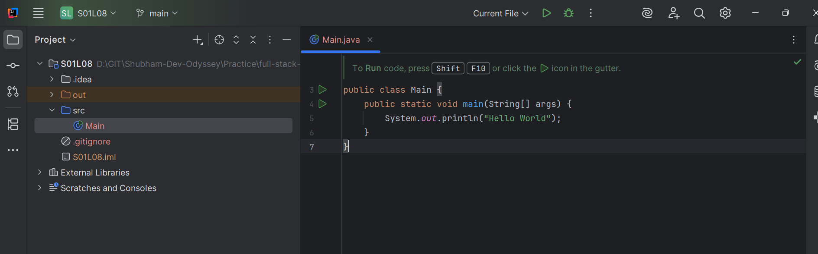
To create Jar file:
- Delete out folder
- Go to file -> project structure
- Click on Artifact then Plus(+) Symbol
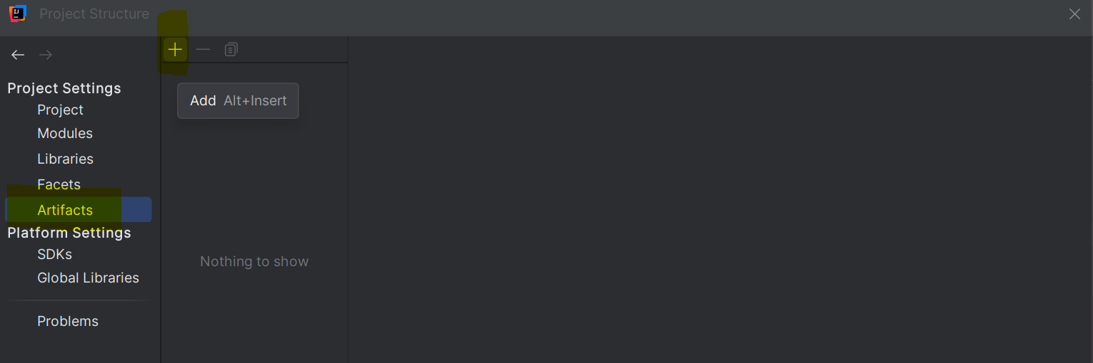
- Select Jar-> From Modules with dependencies
- Select main class and click on OK
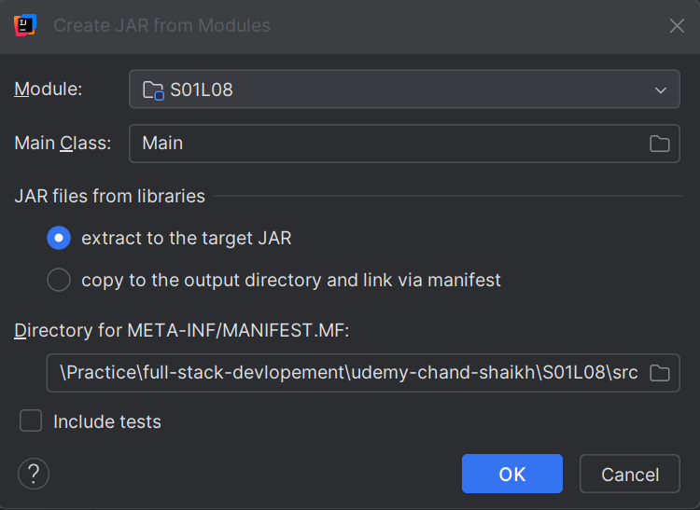
- Click on add
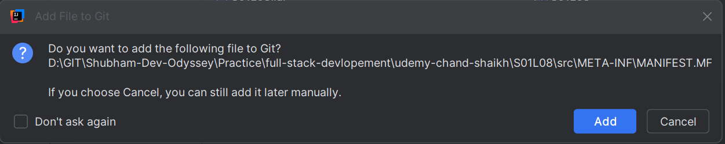
- Click on Apply then OK
- There will be one *.mf file getting created under src/META-INF/MANIFEST.MF
- Right click on this *.mf file -> click on package file
- There will be jar created under out/artifact folder
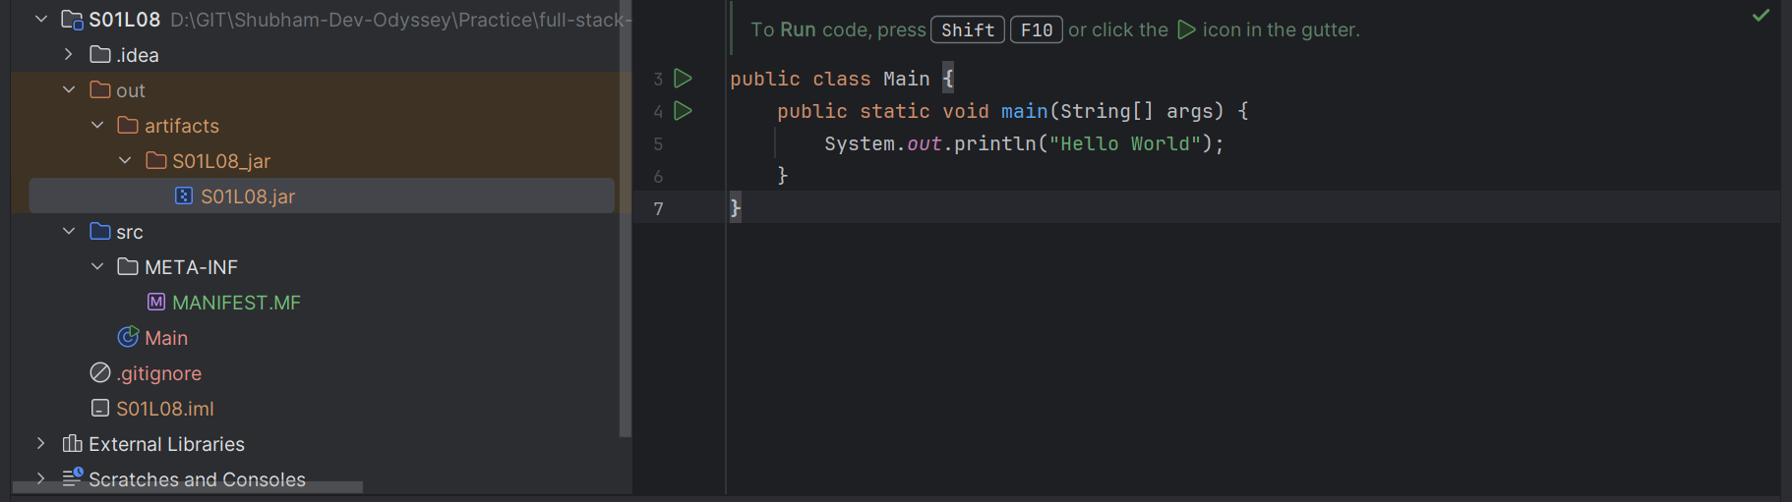

We can run Jar file In IntelliJ IDE:
- Click on jar file
- Above there is 3 dot click on it-> click on edit
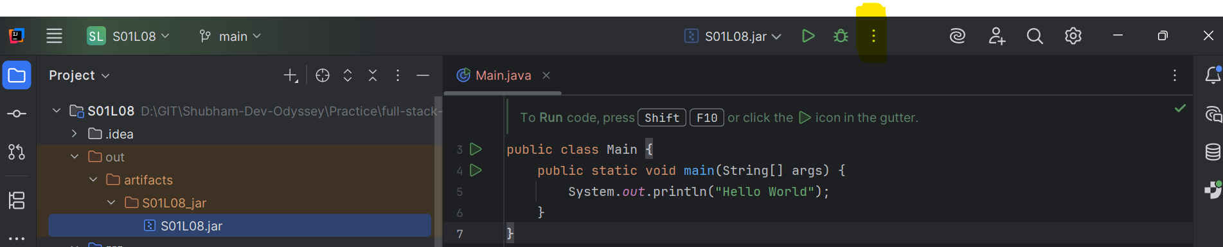
- Below there is before launch section -> click on Plus Symbol(+)
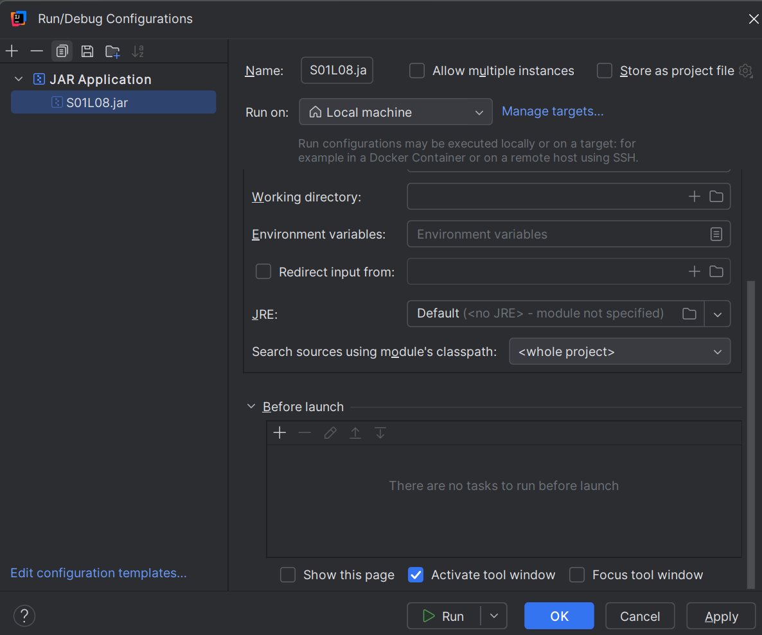
- Select Build Artifact -> select your jar name
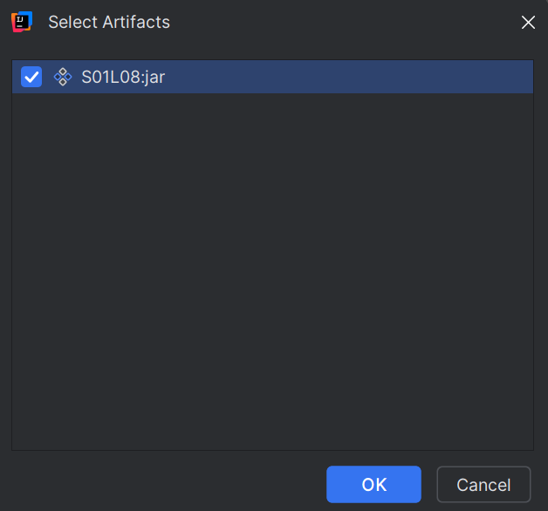
- Click ok -> Click on Apply->Click on Ok
- Right click on jar and then run

How to create Maven projects jar file
- Click on main class
- Edit configuration
- Select Maven
- In side Run add “clean package” (note pom file should have packaging as jar init)
- Click on Apply then click on Run

https://studyeasy.org/course-articles/

In pom file in order to tell what is the starting point of jar after execution we need to add below plugin:

<build>
<plugins>
<plugin>
<groupId>org.apache.maven.plugins</groupId>
<artifactId>maven-jar-plugin</artifactId>
<version>3.1.0</version>
<configuration>
<archive>
<manifest>
<mainClass>org.example.Main</mainClass>
</manifest>
</archive>
</configuration>
</plugin>
</plugins>
</build>
Save pom and clean package -> now when jar created we can directly run it
KEYWORDS AND VARIABLES

KEYWORDS:
- Keywords are reserve words.
- Meaning of word, is known to compiler.
- Keyword cannot be used as name of variable.
- Keywords are case sensitive.

_ // underscore, reserved (since Java 9)
abstract
assert
boolean
break
byte
case
catch
char
class
const // reserved, not currently used
continue
default
do
double
else
enum
exports // module-system keywords (Java 9+)
extends
final
finally
float
for
if
implements
import
instanceof
int
interface
long
module // module keywords
native
new
package
permits // sealed / permission keywords
private
protected
public
record // Java 14+ data type declaration
requires // module keywords
return
short
static
strictfp
super
switch
synchronized
this
throw
throws
transient
try
var // local variable type inference (Java 10+)
void
volatile
while
yield // switch expression / pattern matching (Java 13+)
sealed // Java 15+ (sealing classes/interfaces)
non-sealed // for classes allowed under sealed

NOTE:
- const and goto are reserved but not used. You can’t use them as identifiers.
- true, false, null are literals, not keywords (though reserved in identifiers).
- Some keywords are new in module-system / sealed / record / pattern matching etc., so older Java versions don’t have them.

